# Running QAQC Tool

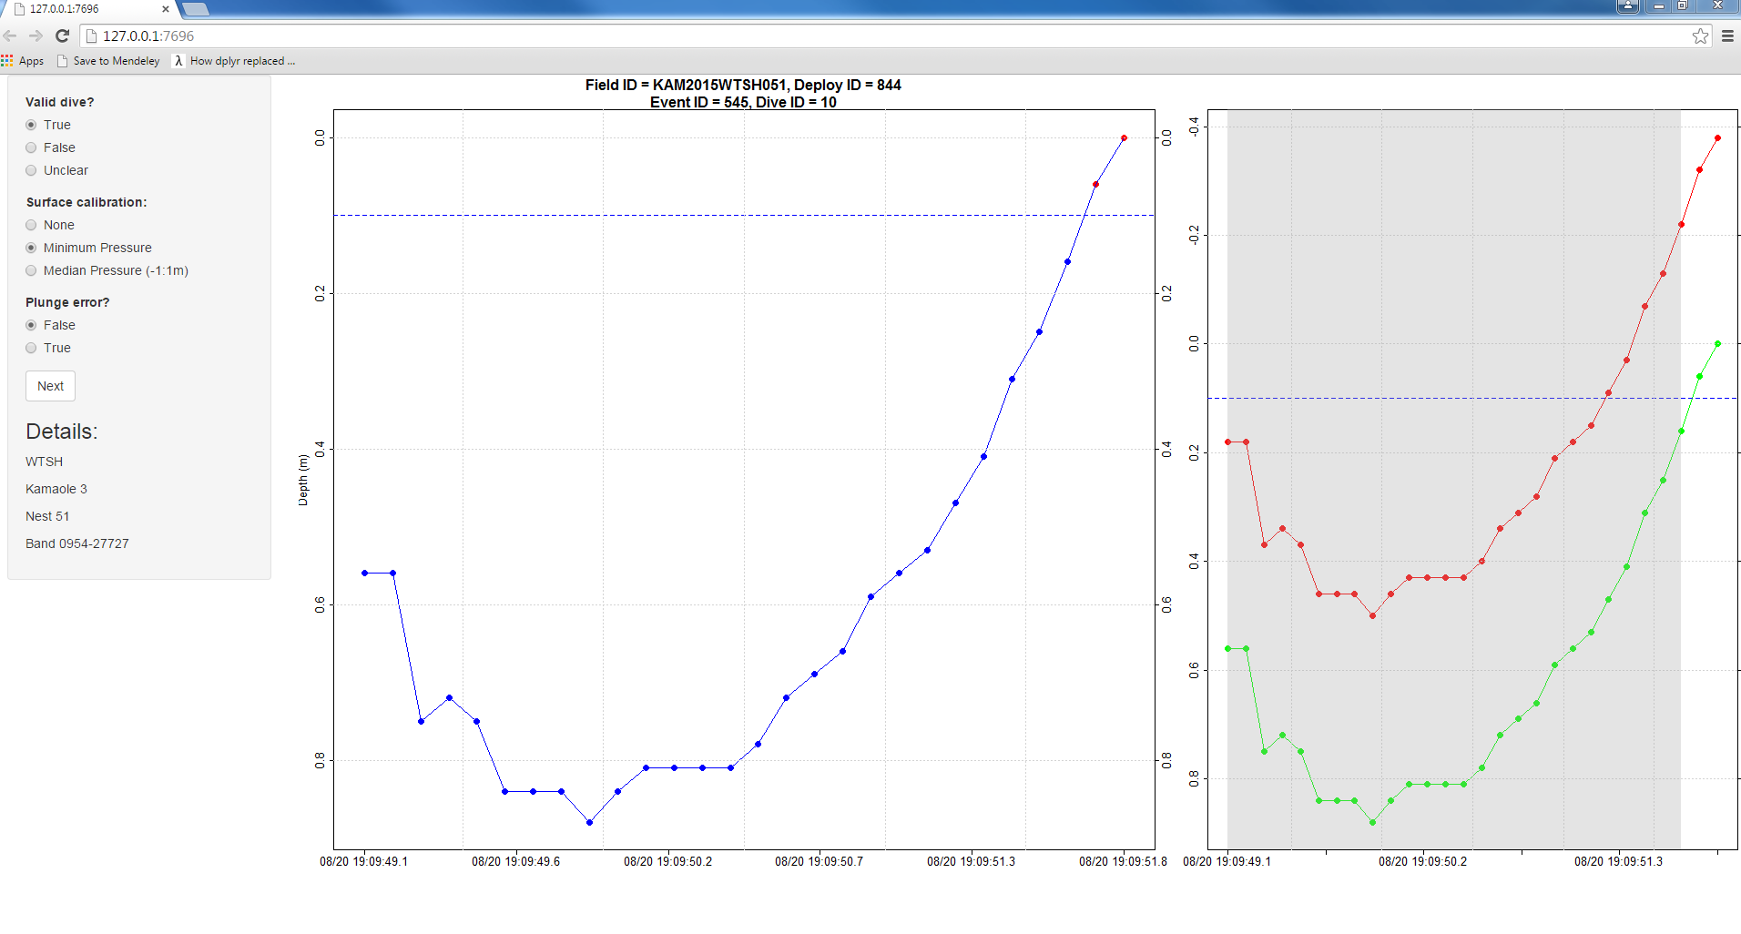

A browser-based tool for rapidly verifying dive data. Runs locally using the shiny package for R.

## Setup

1. Sync with GitHub
   1. Commit ea5e7c on 5/24/2016 contains the relevant code.
   2. Sync to the master branch to get up to date.
2. Sync with Google Drive
   1. You’ll need the files in www. This folder is saved in Google Drive under tracking_data/TDR/QAQC/WTSH.
   2. Download www and extract it to WERC-SC/dive_identification/QAQC.
3. Download necessary R packages
   1. Open RStudio
   2. If you’re missing either of the following packages, install them:
      1. shiny
      2. dplyr
4. Run app
   1. From within RStudio, open WERC-SC/dive_identification/QAQC/ui.R.
   2. Set the app to Run External using the dropdown in the top right corner of the code frame

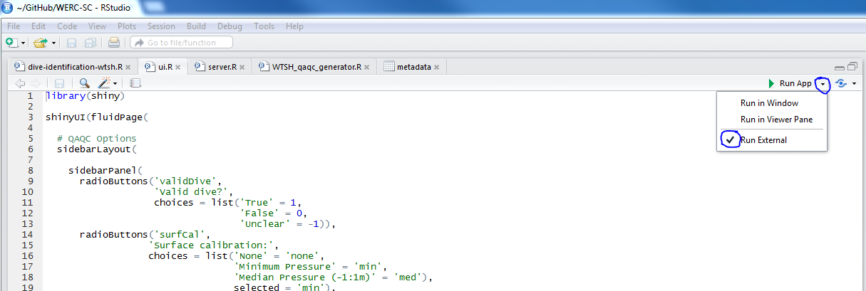

* 1. Click on the green play arrow to open the app in your browser